📊 Sales Data Analysis Report
Gold Layer – Analytical Insights

📌 Project Overview
This report provides a complete sales analysis performed on the Gold Layer of the SQL Data Warehouse. The purpose is to understand sales performance, customer behaviour, product contribution, and category-level insights using SQL analytics.
All analysis is based on:
- Dimensional Model (Fact + Dimensions)
- Star Schema Design
- SSMS SQL Queries

🧱 1. Yearly Sales Performance
Analysis how sales performed year-over-year, including customer count and quantity sold.
SQL Query
1. SELECT
2. YEAR(order_date) AS order_year,
3. SUM(sales_amount) AS total_sales,
4. COUNT(DISTINCT customer_key) AS total_customers,
5. SUM(quantity) AS total_quantity
6. FROM gold.fact_sales
7. WHERE order_date IS NOT NULL
8. GROUP BY YEAR(order_date)
9. ORDER BY order_year;
10.

📌 Purpose
- Identify sales growth trends
- Monitor customer base expansion
- Support financial forecasting

📷 Result (Paste Screenshot Here)
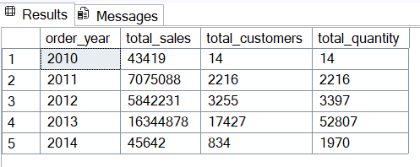

📈 2. Cumulative Sales Trend (Running Total)
Tracks how revenue accumulates year after year.
SQL Query
1. SELECT
2. order_date,
3. total_sales,
4. SUM(total_sales) OVER (ORDER BY order_date) AS running_total_sales
5. FROM (
6. SELECT
7. DATETRUNC(YEAR, order_date) AS order_date,
8. SUM(sales_amount) AS total_sales
9. FROM gold.fact_sales
10. WHERE order_date IS NOT NULL
11. GROUP BY DATETRUNC(YEAR, order_date)
12. ) AS T;
13.
📌 Purpose
- Understand compounding growth
- Identify high/low acceleration years
- Used for dashboards & KPIs

📷 Result
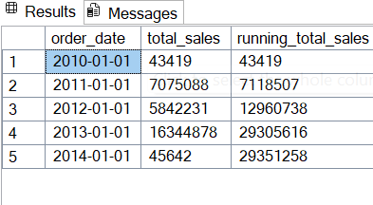

🛒 3. Product Performance (YoY + Benchmarking)
Identifies top and bottom performing products compared to the product average and previous year.
SQL Query
1. WITH yearly_product_sales AS (
2. SELECT
3. YEAR(f.order_date) AS order_year,
4. SUM(f.sales_amount) AS current_sales,
5. p.product_name
6. FROM gold.fact_sales f
7. LEFT JOIN gold.dim_products p
8. ON f.product_key = p.product_key
9. WHERE f.order_date IS NOT NULL
10. GROUP BY YEAR(f.order_date), p.product_name
11. )
12. SELECT
13. product_name,
14. order_year,
15. current_sales,
16. AVG(current_sales) OVER (PARTITION BY product_name) AS avg_sale_by_product,
17. current_sales - AVG(current_sales) OVER (PARTITION BY product_name) AS diff_from_avg,
18. CASE
19. WHEN current_sales > AVG(current_sales) OVER (PARTITION BY product_name) THEN 'Above Average'
20. WHEN current_sales < AVG(current_sales) OVER (PARTITION BY product_name) THEN 'Below Average'
21. ELSE 'At Average'
22. END AS performance_flag,
23. LAG(current_sales) OVER (PARTITION BY product_name ORDER BY order_year) AS previous_year_sales,
24. current_sales - LAG(current_sales) OVER (PARTITION BY product_name ORDER BY order_year) AS yoy_difference
25. FROM yearly_product_sales
26. ORDER BY product_name, order_year;
27.

📷 Result
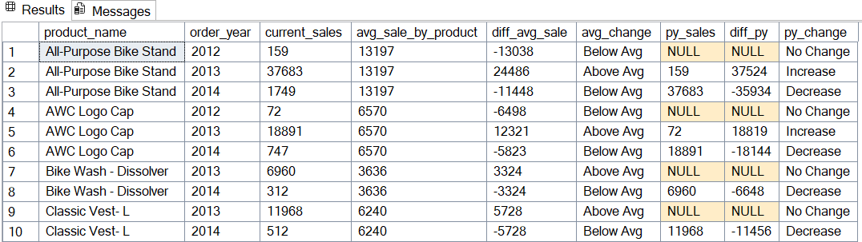

🏷️ 4. Category Contribution (Share of Sales)
Determines which product category drives the highest revenue share.
SQL Query
1. WITH category_sales AS (
2. SELECT
3. p.category,
4. SUM(f.sales_amount) AS total_sales
5. FROM gold.fact_sales f
6. LEFT JOIN gold.dim_products p
7. ON p.product_key = f.product_key
8. GROUP BY p.category
9. )
10. SELECT
11. category,
12. total_sales,
13. CONCAT(
14. ROUND((CAST(total_sales AS FLOAT) / SUM(total_sales) OVER()) * 100, 2), '%'
15. ) AS sales_percentage
16. FROM category_sales
17. ORDER BY total_sales DESC;
18.
📷 Result
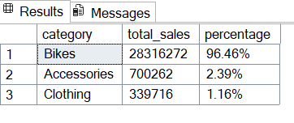

👥 5. Customer Segmentation
Purpose:
- To group data into meaningful categories for targeted insights.
- For customer segmentation, product categorization, or regional analysis.

1 Segment: Segment products into cost ranges and
count how many products fall into each segment

1. WITH product_segments AS (
2. SELECT
3. product_key,
4. product_name,
5. cost,
6. CASE
7. WHEN cost < 100 THEN 'Below 100'
8. WHEN cost BETWEEN 100 AND 500 THEN '100-500'
9. WHEN cost BETWEEN 500 AND 1000 THEN '500-1000'
10. ELSE 'Above 1000'
11. END AS cost_range
12. FROM gold.dim_products
13. )
14. SELECT
15. cost_range,
16. COUNT(product_key) AS total_products
17. FROM product_segments
18. GROUP BY cost_range
19. ORDER BY total_products DESC;
20.

Result:

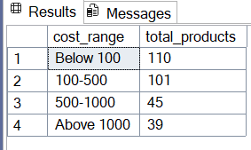

2 Segment:
Group customers into three segments based on their spending behavior:
- VIP: Customers with at least 12 months of history and spending
more than €5,000.
- Regular: Customers with at least 12 months of history but
spending €5,000 or less.
- New: Customers with a lifespan less than 12 months.
And find the total number of customers by each group

Query:

1. WITH customer_spending AS (
2. SELECT
3. c.customer_key,
4. SUM(f.sales_amount) AS total_spending,
5. DATEDIFF(month, MIN(order_date), MAX(order_date)) AS lifespan,
6. CASE
7. WHEN DATEDIFF(month, MIN(order_date), MAX(order_date)) >= 12
8. AND SUM(f.sales_amount) > 5000 THEN 'VIP'
9. WHEN DATEDIFF(month, MIN(order_date), MAX(order_date)) >= 12
10. AND SUM(f.sales_amount) <= 5000 THEN 'Regular'
11. ELSE 'New'
12. END AS customer_segment
13. FROM gold.fact_sales f
14. LEFT JOIN gold.dim_customers c
15. ON f.customer_key = c.customer_key
16. GROUP BY c.customer_key
17. )
18.
19. SELECT
20. customer_segment,
21. COUNT(customer_key) AS total_customers
22. FROM customer_spending
23. GROUP BY customer_segment
24. ORDER BY total_customers DESC;
25.

Result :

